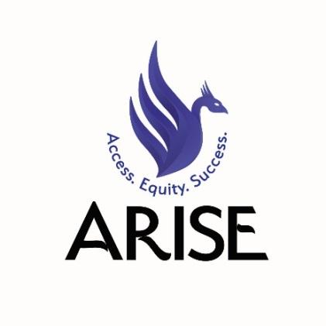

Alliance of Rhode Island Southeast Asians for Education

Youth Leader Application

Due Date: Wednesday, October 24
Start Date: Monday, November 12
Duration: 9 months minimum

Position Description:
ARISE Youth Leaders will be responsible for leading a Providence Public School District Educational Justice Campaign in coalition with Providence Youth Student Movement (PrYSM). Youth Leaders will participate in ARISE political education, leadership, and organizing workshops, as well as weekly campaign planning meetings with PrYSM. They are expected to perform community outreach to recruit students to ARISE programming, as well as to ensure that campaign work centers the voices of Southeast Asian and other impacted youth. Youth Leaders will receive a monthly stipend in recognition of their work.
For more information, please visit: http://www.ariseducation.org/youth-leaders/

Applicant must be:
- A high school student from the Providence, Cranston & Woonsocket School District
- Able to commit 4-6 hours a week from 11/12/18 to 7/31/19
- Committed and passionate about justice in the public education system
- Positive and self-motivated
- Someone who works to build strong relationships and resolve conflict
- Someone with strong organization, planning & communication skills
- Someone who believes in being part of the change they want to see happen!

If Interested:
Please submit responses to the below questions to our Educational Justice Coordinator, Anusha Alles, (anusha@ariseducation.org) by Wednesday, 10/24/18. If you do not have access to the internet and need to drop off a paper copy, please contact Anusha by phone (8172290645). Applications will be reviewed by ARISE staff and anonymously by current Youth Leaders. You will be contacted on Friday, 10/26/18 regarding the status of your application.

Short Answer Questions
- How do you name your ethnic identity? Please use as many words as you feel appropriate. (ex. Khmer, Hmong, Laotian, African American, Latinx)

- How do you name your gender identity? Please use as many words as you feel appropriate. (ex. nonbinary, transgender, cisgender, male, female, Two Spirit)

- How do you name your sexual identity? Please use as many words as you feel appropriate. (ex. gay, lesbian, queer, bisexual, straight, questioning)

- What school do you attend and what year are you in?

- What other activities do you participate in and what is the time commitment (babysitting, AP classes, jobs, sports, dance team, etc.)? Please mark the boxes below to indicate time slots when you are available this school year.

 | M | T | W | Th | F
3-4 PM
4-5 PM
5-6 PM
6-7 PM

Reflection Questions
Please restrict answers to 150 words max per question.

- Please consider our October 20th orientation and review the requirements and description of our program online: www.ariseducation.org/youth-leaders. What aspects of our program are you excited about?

- What skills are you bringing to the Youth Leader program? What skills would you like to develop?

- What role do you usually play in a team? How do you support others when you’re working together?

- What makes a group of people a community? With whom are you in community? With whom would you like to build community?

- What do you think educational justice looks like? Why are you committed to this work?

